**Coursework 2: Analysis report**

**Descriptive statistics**

**Referendum analysis**

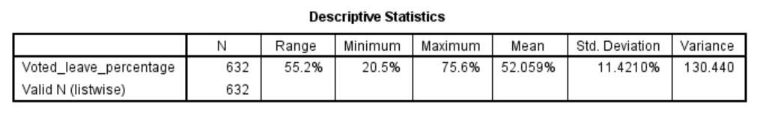The table shows that the referendum done in UK generally 52% of the population were of the opinion that UK should leave the EU. The boxplots illustrates that the signature count in England and Scotland were normally distributed but had many outliers except Northern Ireland and wales.

**Petitions table analysis**

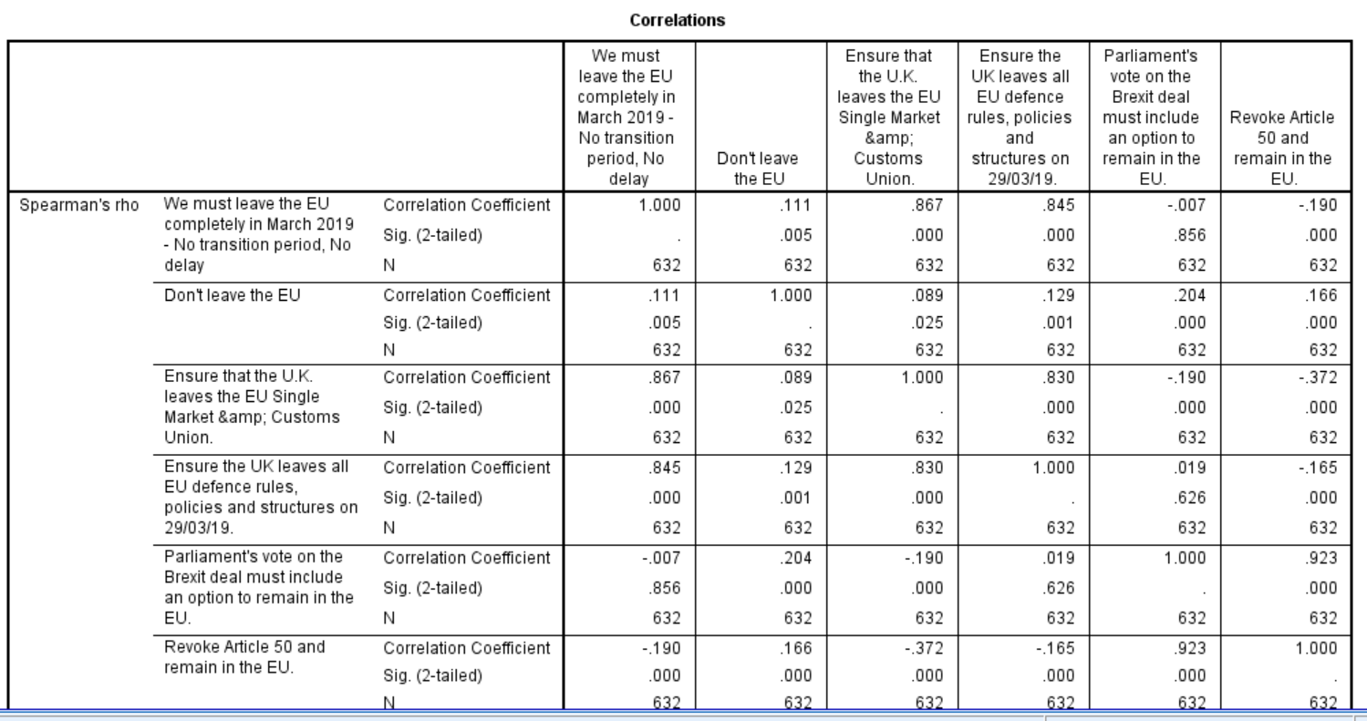

The pro-leave petitions were highly correlated amongst themselves, this means that the pattern of one pro-leave petition are similar because they move in the same direction. This is the same for pro-remain petitions also, whereas the correlation of pro-leave and pro-remain is so small, therefore suggesting that they are independent of each other.

**Population analysis by Age**

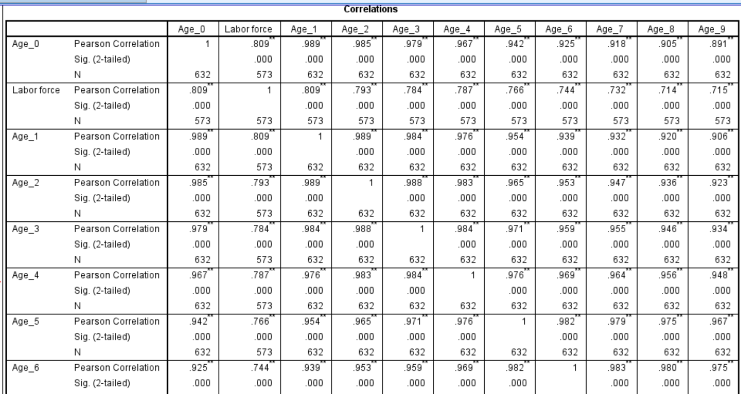

The correlation of children population and the working population is very high indicating that the more the children a constituency has the more the labor force in that constituency.

**Jobs/Employment analysis**

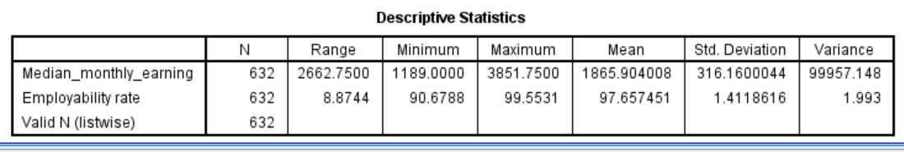

The average employment rate was 51.21%, the standard deviation in earnings was 3893. Both the employment rate and median monthly earnings are normally distributed as shown by bell shaped density curves on the histograms.

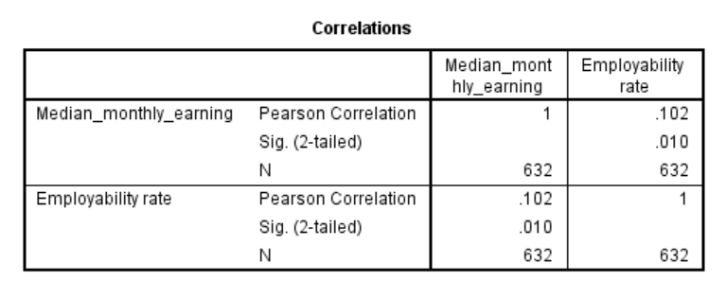

Employment rate and median employment earnings have very small positive correlation, this means that they have close to being independent of each other, thus the employability rate was independent of the median monthly income in 2016.